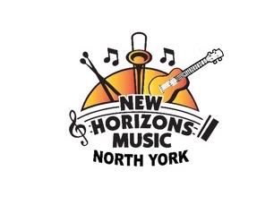
NHMNY UKE CLASS

Tuesday Mornings
Sept 2025-June 2026

SIGN-UP FORM

NAME: _________________________________________ _____________________________________________
First Name Surname

EMAIL ADDRESS: _______________________________________________________________________________

PHONE NUMBER: ________________________________________
EMERGENCY CONTACT NAME: _______________________________________________________

EMERGENCY CONTACT NUMBER: ____________________________________________________

FEE and PAYMENT METHOD:

___ Returning NHMNY Member: $400

___ New Member $425

___ E-transfer to: nhmnorthyork@gmail.com

___ Email registration form to nhmnorthyork@gmail.com

___ Cheque to: New Horizons Music North York
Susan Baskin
New Horizons Music North York,
74 Lyndhurst Avenue,
Toronto, Ontario, M5R27Z

Questions? 416-721-2748 or nhmnorthyork@gmail.com
For more information: www.newhorizonsmusicnorthyork.ca

